Name: Harshalk

Std: TYBSCIT

Roll no: 16

Subject: DMBI

(Practical No 1)

Signature:

Practical 1A: Installation of Power BI Desktop

Step 1: Go to Microsoft Store and search for power bi, click on Power BI Desktop.



Step 2: Click on Get button.

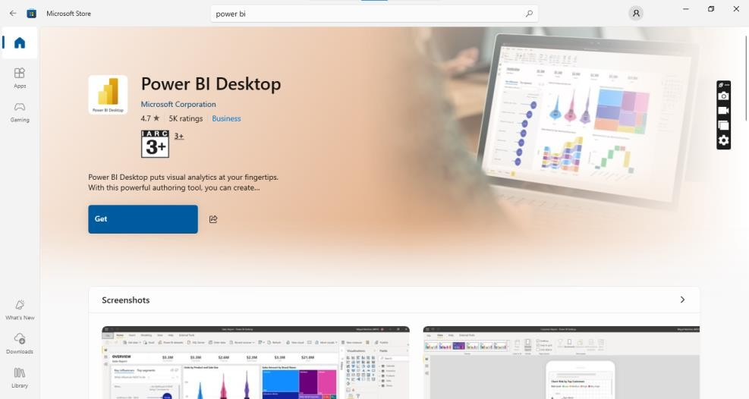

Step 3: The installation will start. Click on Open once the installation is complete and start working.



Practical 1B: Import the legacy data from different sources such as Excel, SQL Server and OData Field and load into the target system

Step 1: Open Microsoft Power BI and select Excel Workbook under the Get Data option. Click on Connect.

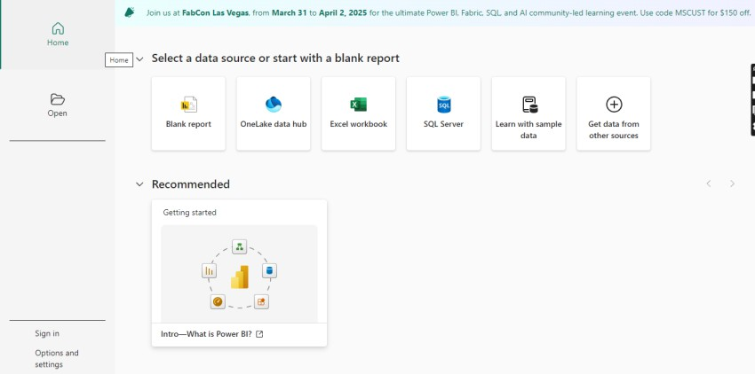

**Step 3: Browse your file and select it.**

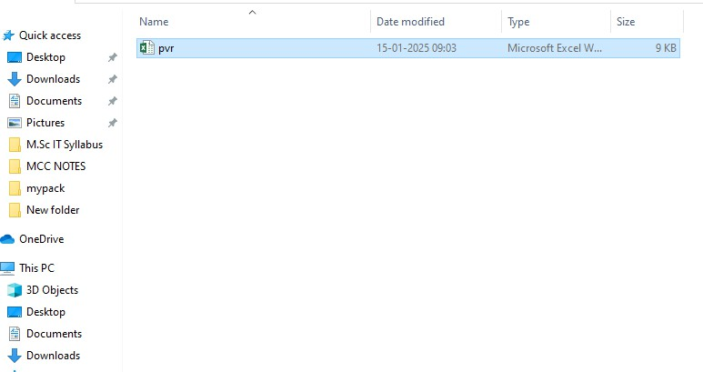

Step 4: Select the sheet and click on Load once the table is displayed.

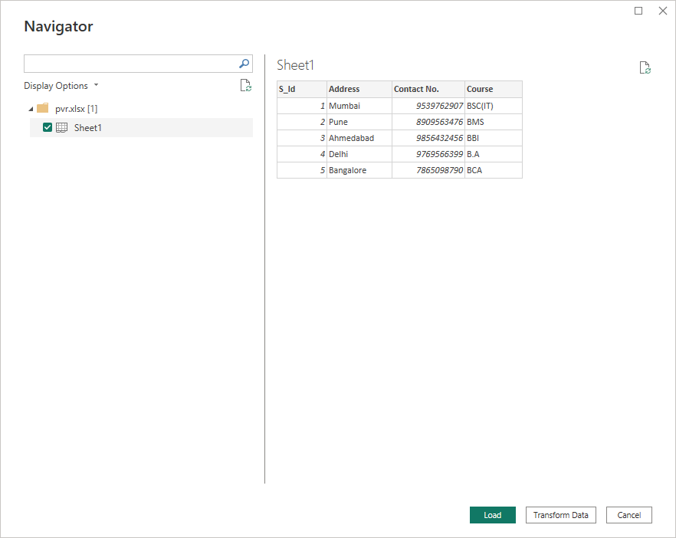

Step 5: Wait for the loading to complete.

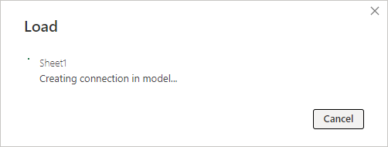

Step 6: The data will be shown on the screen once the loading is complete.

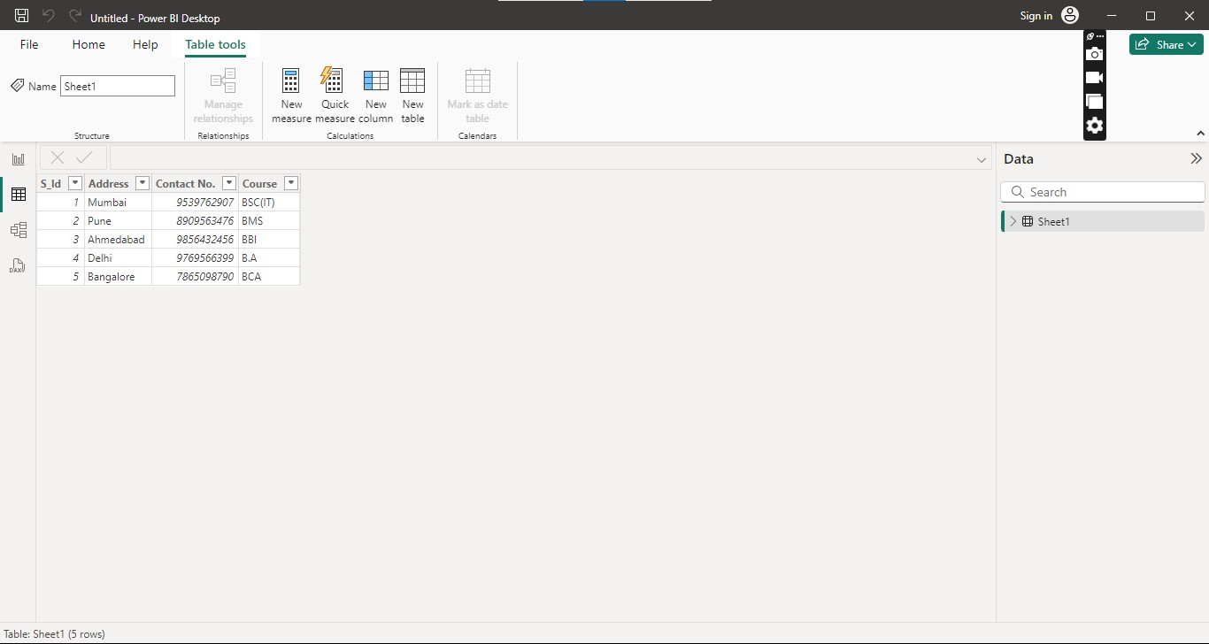

Step 7: Click on the Charts icon to display the graphical representation of the data.

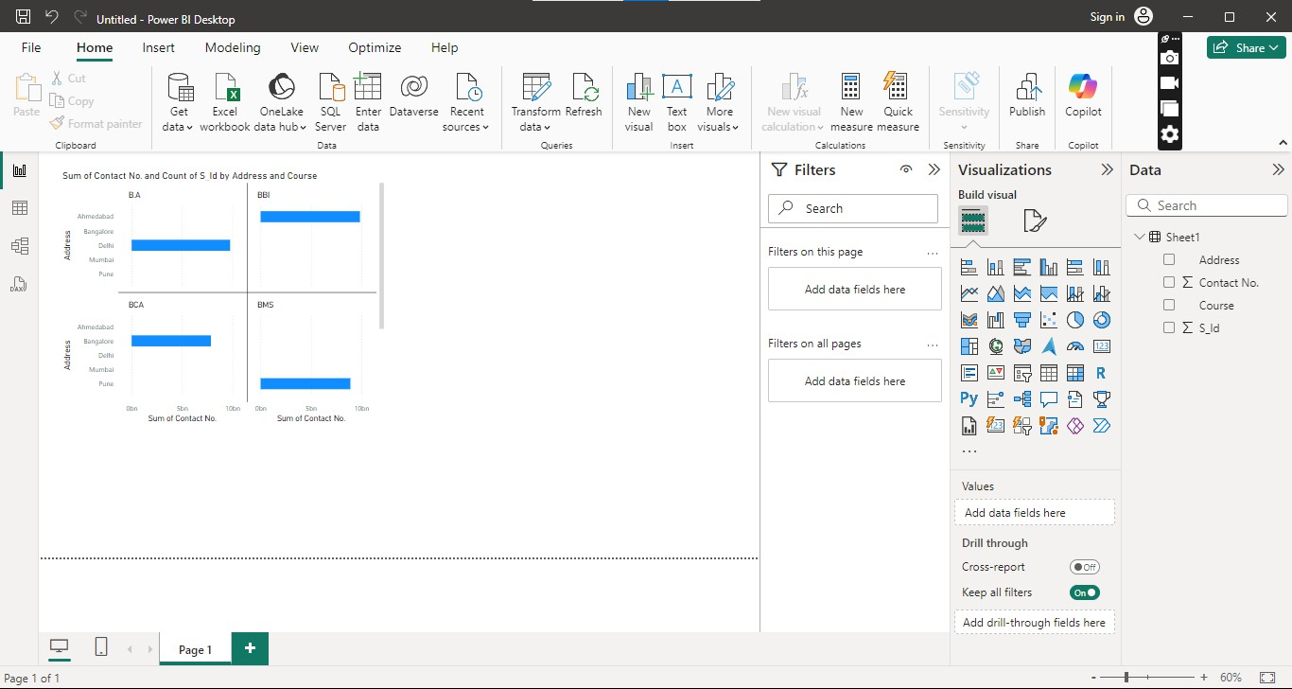

Step 8: Click on Get Data and select SQL Server Database.

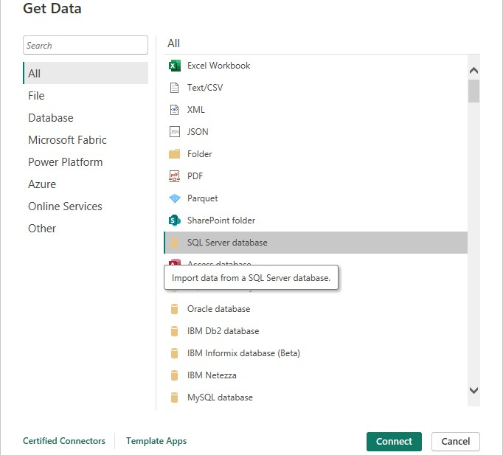

Step 9: Copy the server’s name from Microsoft SQL Server Management Studio & paste it where the server is asked for connection between the two apps. Select Import & click OK.

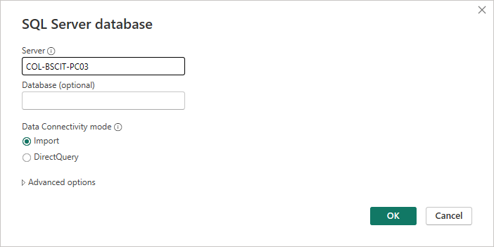

Step 10: Select the table you wish to go ahead with and load it.

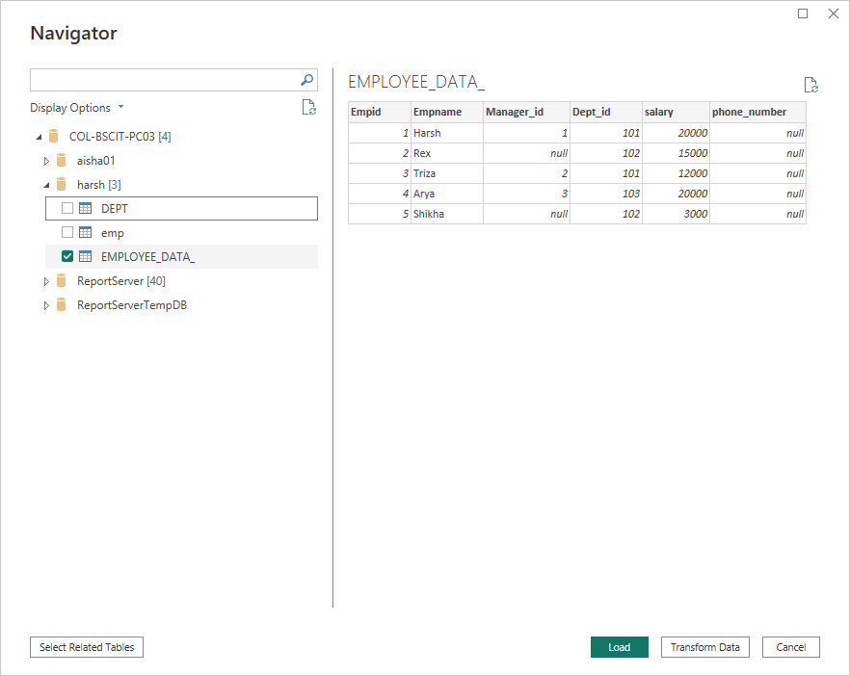

Step 11: Once the data is loaded. The data will be displayed on the screen.

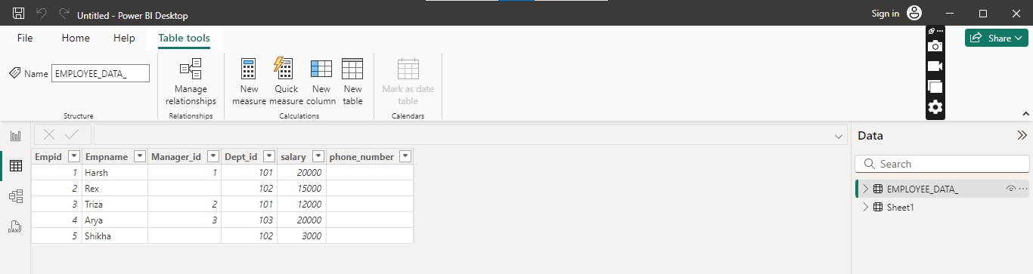

Step 12: On clicking the charts icon the graphical representation of the data will be displayed.

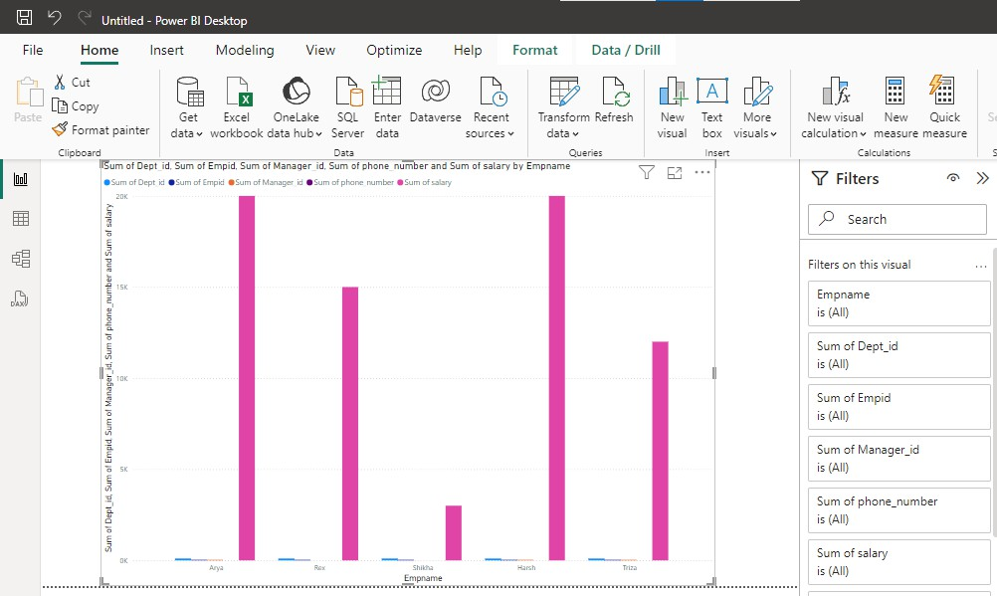

Step 13: Select SQL Server Database under Get Data and connect.

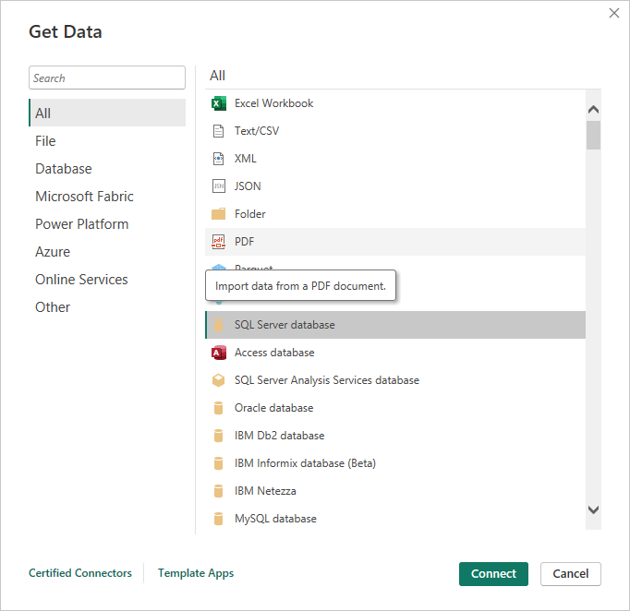

Step 14: Enter the server name and the file name with .bak extension. Click on Import and OK

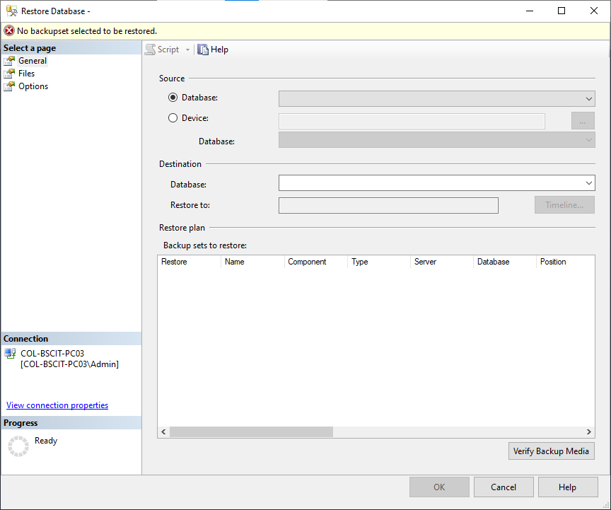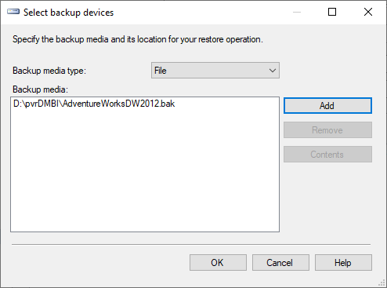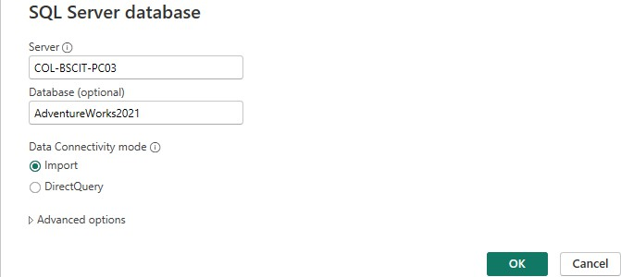

Step 15: Open Microsoft SQL Server Management Studio. Right click on Databases and click on Restore Database.

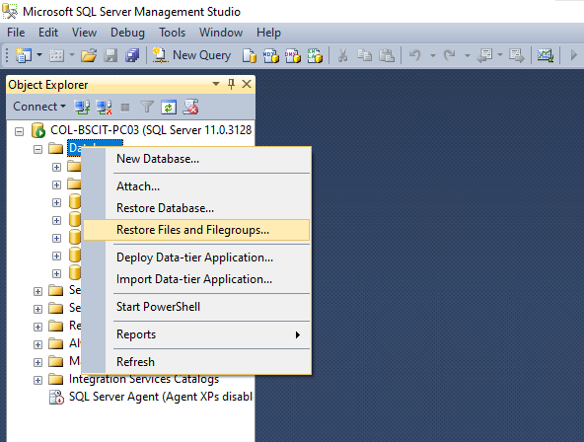

Step 16: Select Device and Add the .bak files

Step 17: Search for another file and add it as well. Next go to Power BI and select Get Data

– O Data Feed and Paste the URL.

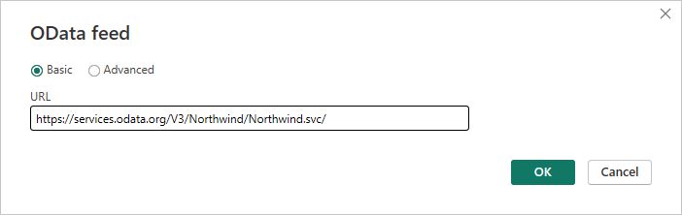

Step 18: Select two tables that are Customers and Products table and load them.

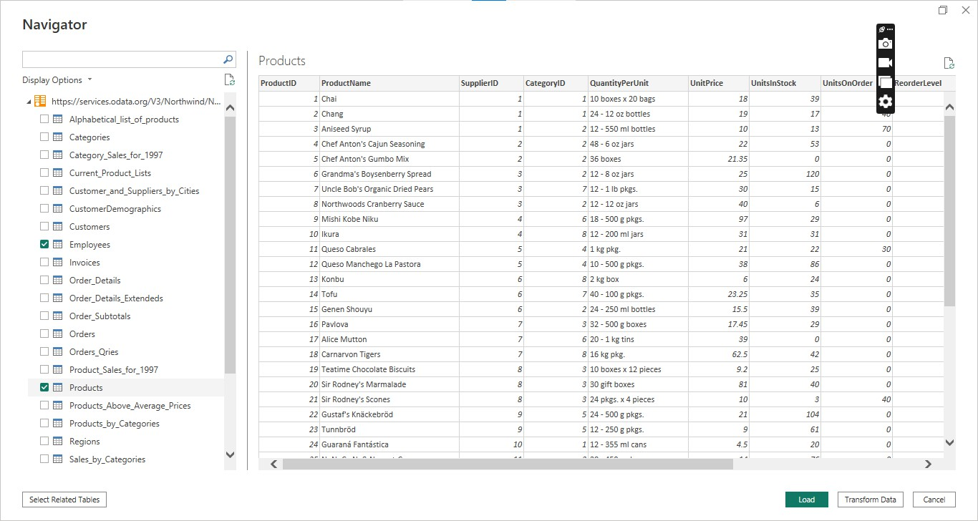

Step 21: Click on the charts icon and select the type of graph to be displayed.

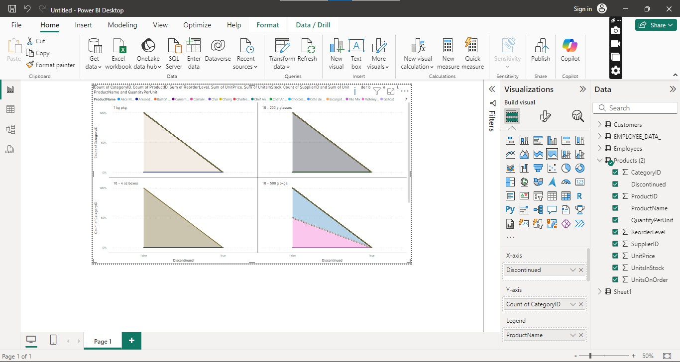

Name: Harshalk

Std: TYBSCIT

Roll no: 16

Subject: DMBI

(Practical No 2a,2b)

Signature:

# Practical 2A: Perform the ETL process to construct the database in SQL Server

Open SQL Server Data Tools. Go to File then New and then Project.

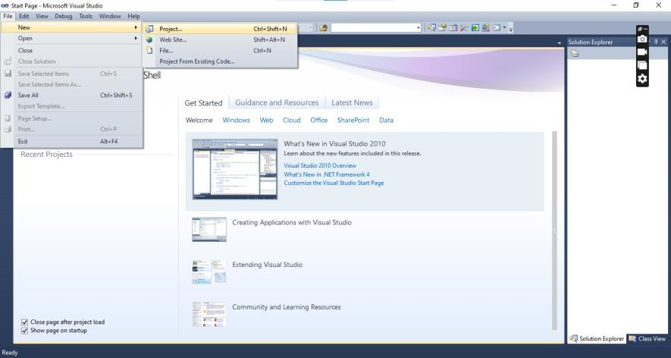

Select Integration Services and select Integration Services Project, rename it as ETL Process.

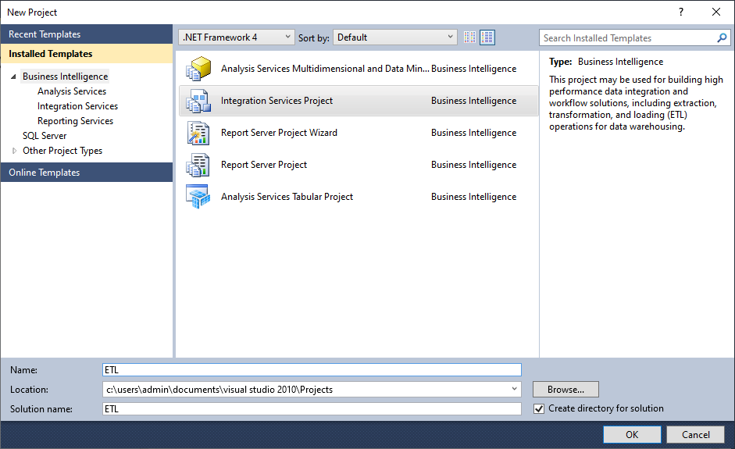

In the Solution Explorer right click on Connection Managers under ETL Process the file name and select the New Connection Manager.

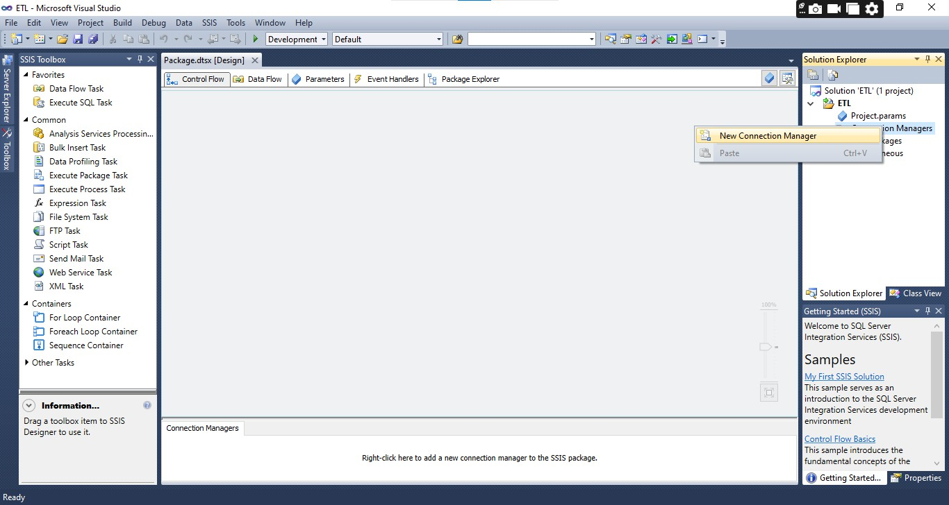

Add OLEDB as the Connection Manager.

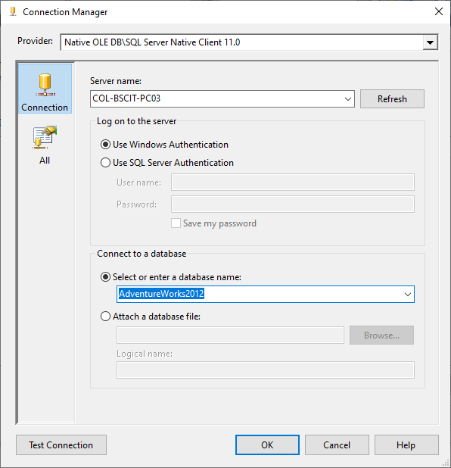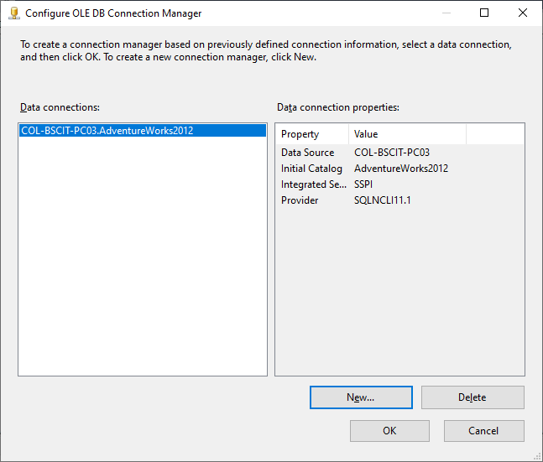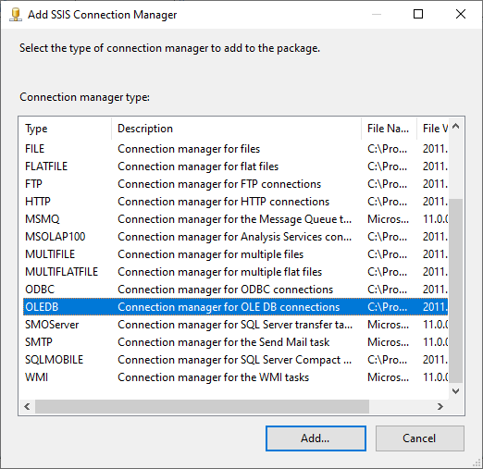

After adding the Connection Manager the following dialogue box will open. Click on New.

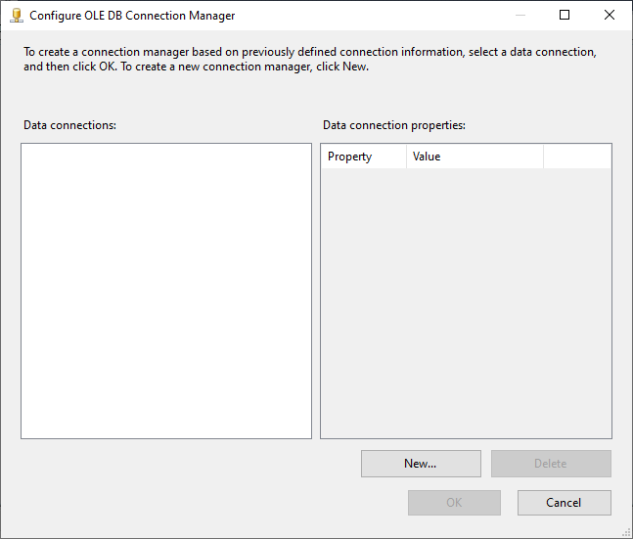

Enter the Server Name and select the database that is AdventureWorks file & click ok

Under Other Sources in the SSIS Toolbox drag and drop OLE DB Source to the screen.

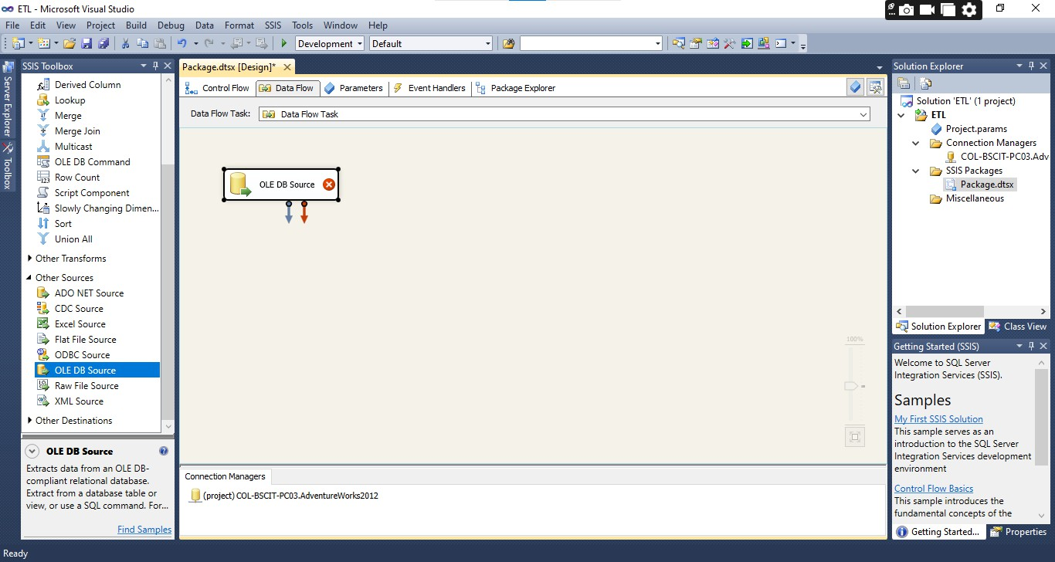

Right click on OLE DB Source. Under Connection Manager enter the OLE DB Connection Manager and the name of the tables by clicking on New.

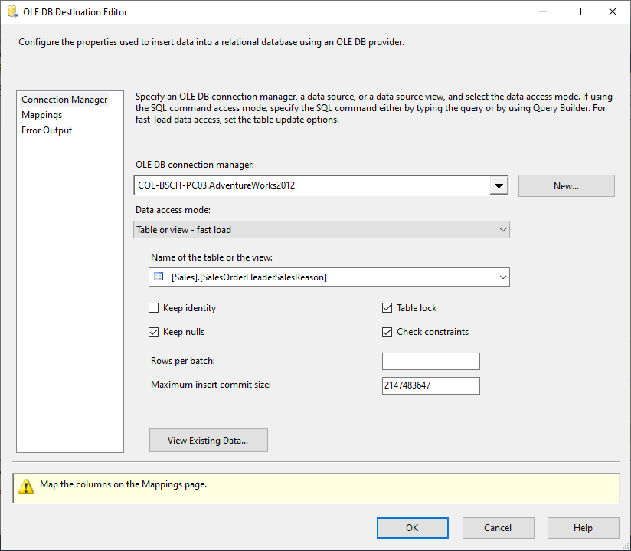

In OLE DB Destination Editor check the Mappings.

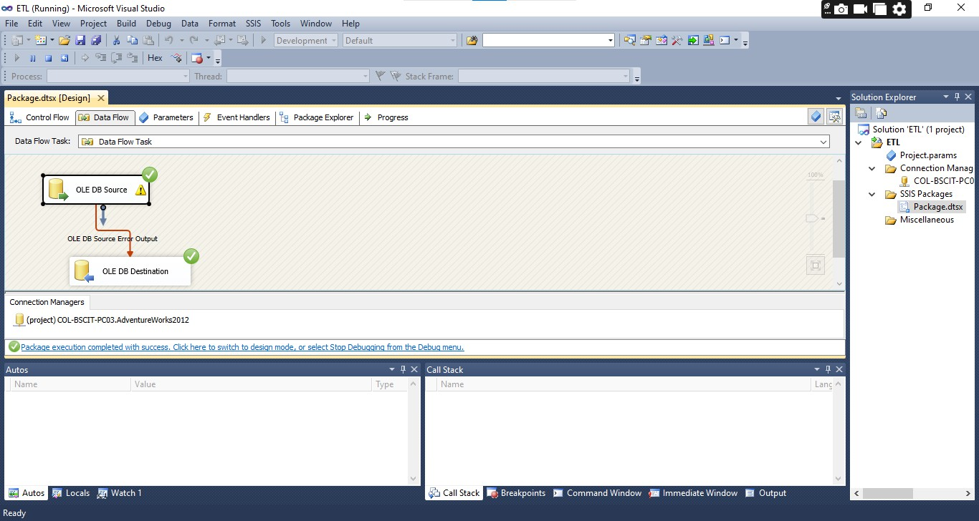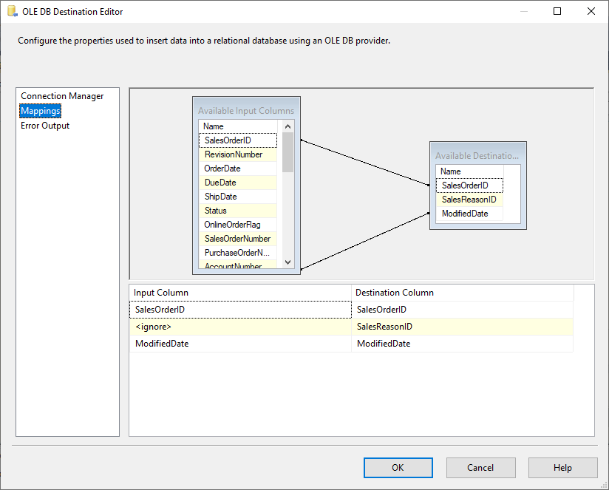

Start the debugging. It should be successful.

# Practical 2B – Perform the ETL process in Power BI

Step 1: Select OData Feed from Get Data and click on Connect. Enter the URL provided that is https://services.odata.org/Northwind/Northwind.svc and click on OK.



Step 2: Select the tables – Orders, Order_Details and Products and load them.

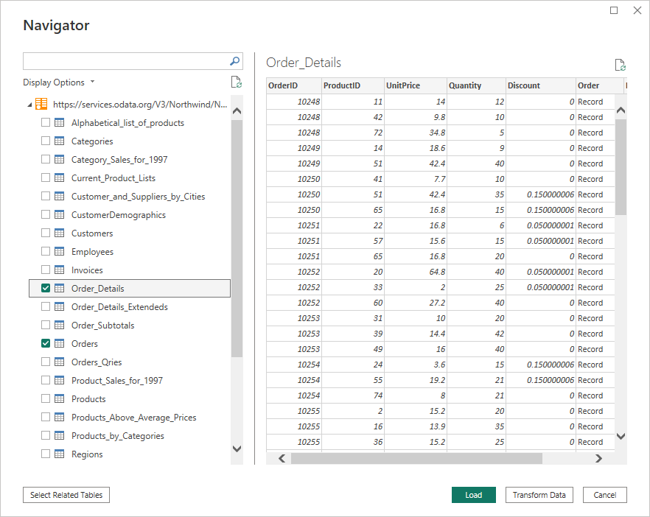

Step 3: Right click on any of the column and select Edit Query

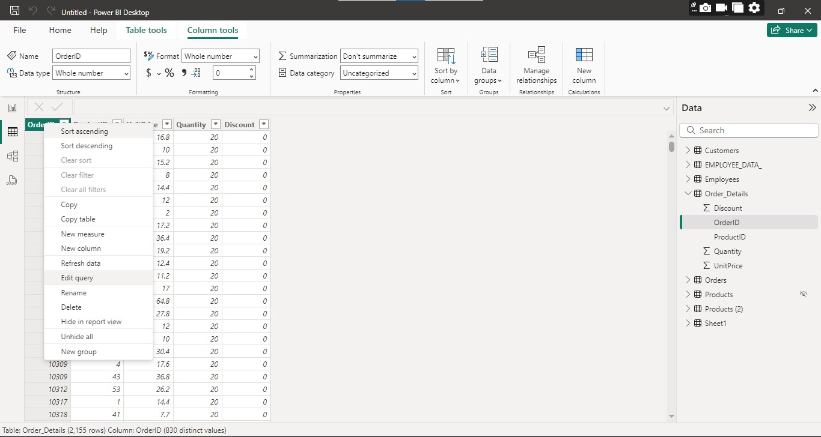

Step 4: A new window will be opened.

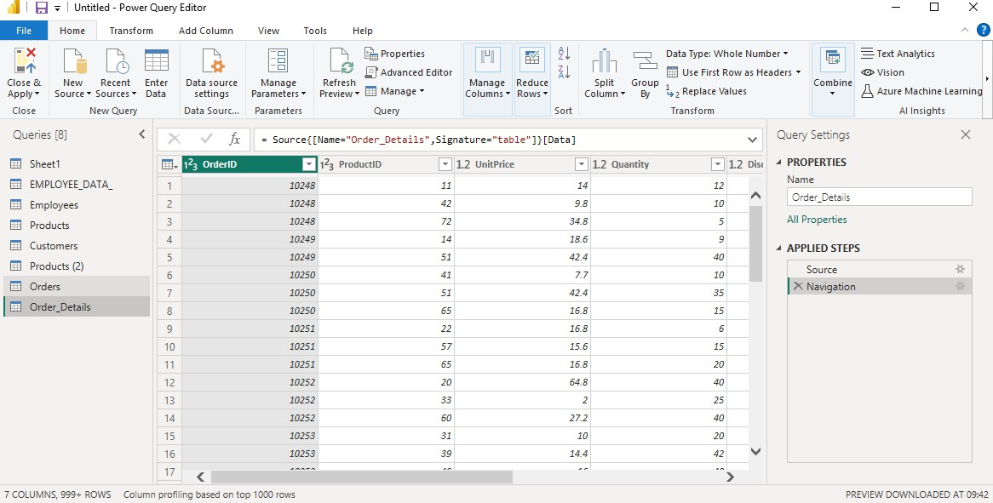

Step 5: Click on Add Column and then Custom Column. Name the column name as LineTotal and enter the formula by inserting the columns as the variables and then click on OK.

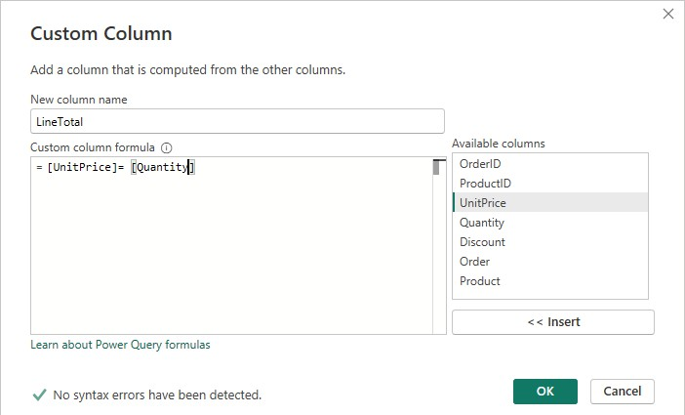

Step 6: The LineTotal column will be added

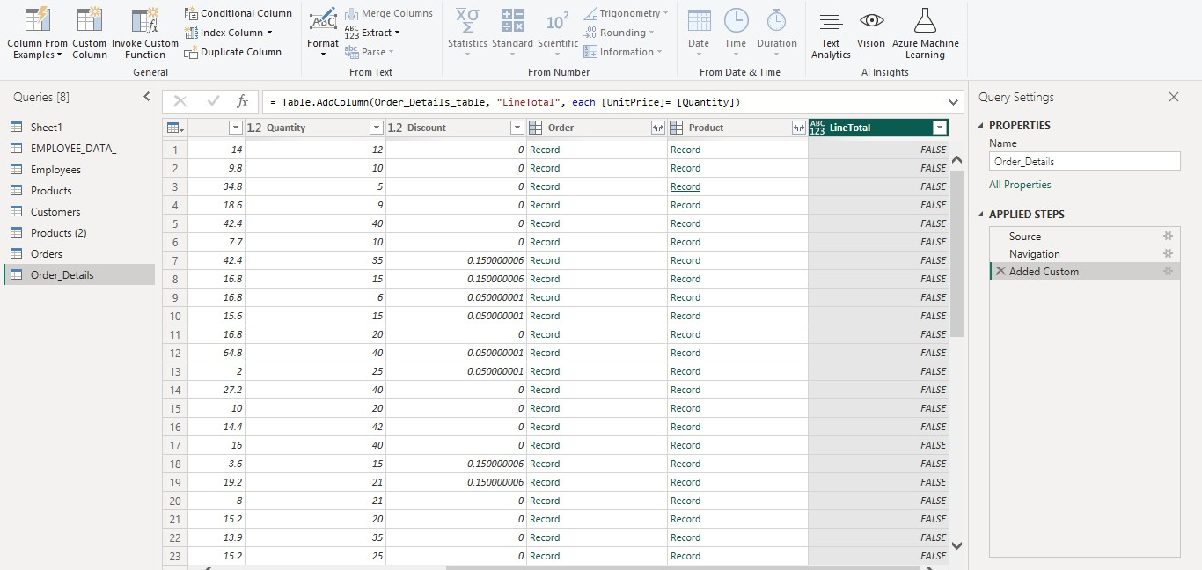

Step 7: Select the Orders table and under Table Tools select Manage Relationships.

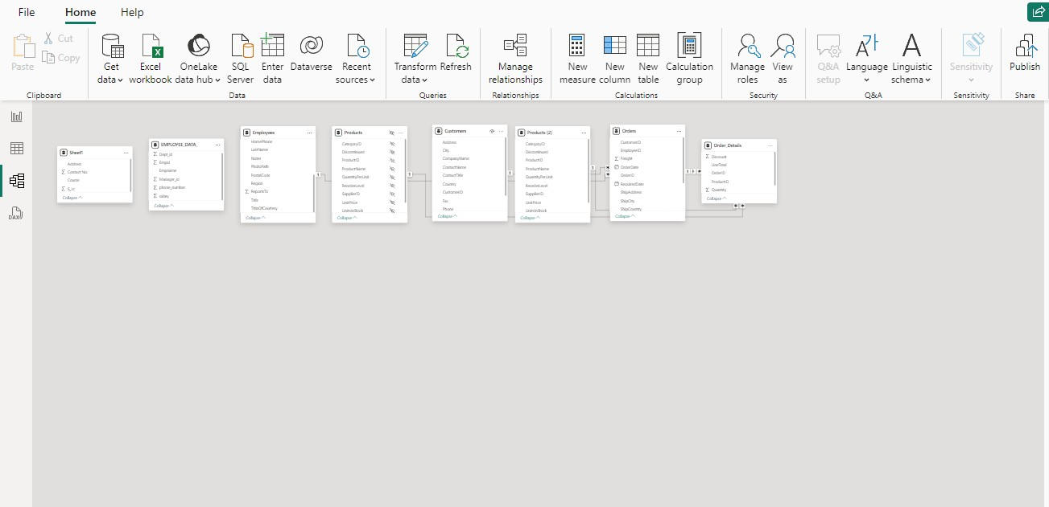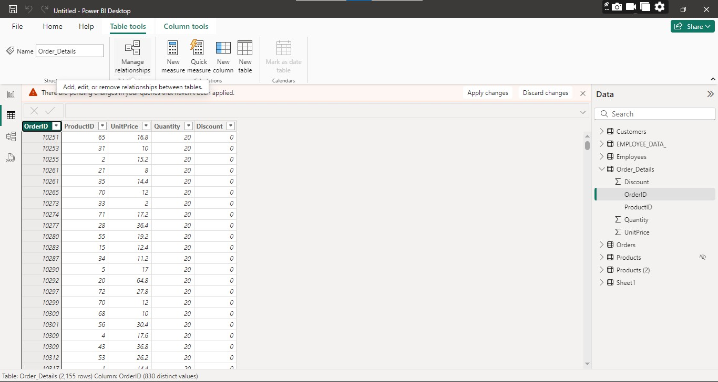

Step 8: Edit the details according to the requirement.

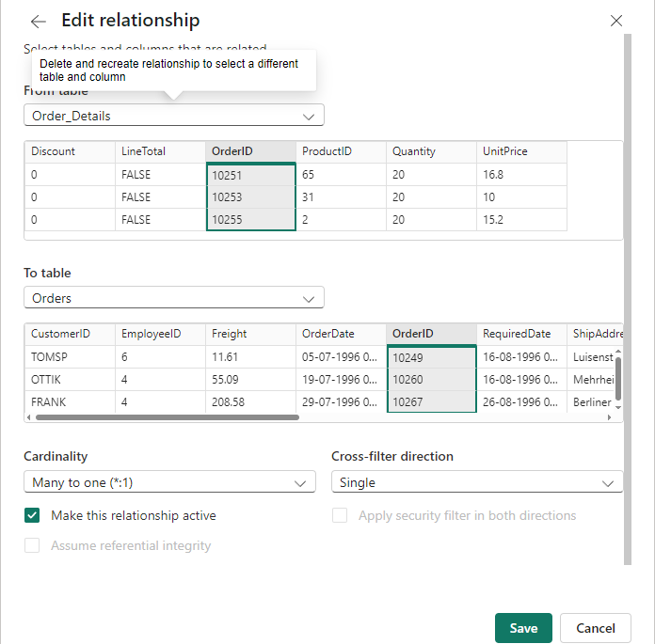

Step 9: Click on the relationship icon.

Name: Harshalk

Std: TYBSCIT

Roll no: 16

Subject: DMBI

(Practical No 3a)

Signature:

# Practical 3A – Perform data visualization in Power BI and create the data staging area for the selected database

Step 1:In Power BI click on File then go to Options and Settings click on Options and check Map and Filled Map Visuals. Click on OK.

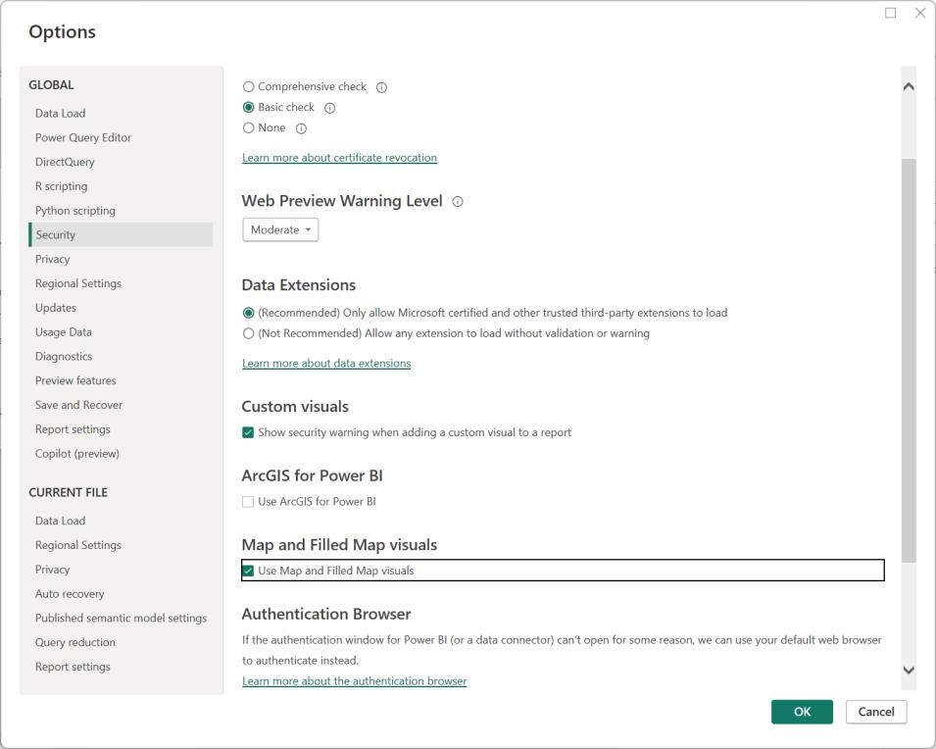

Step 2: Open a table. Right click on any column and select Edit query.

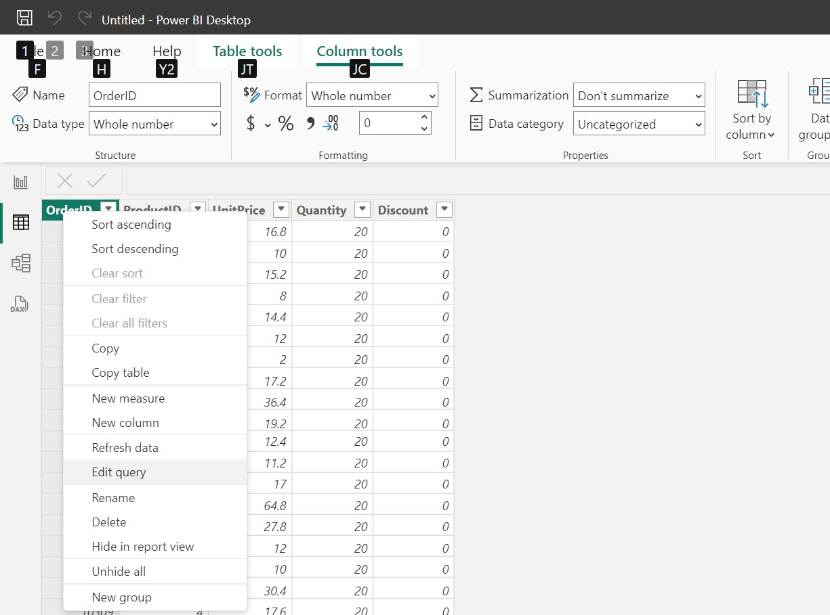

Step 3: Another window will be opened which look like below.

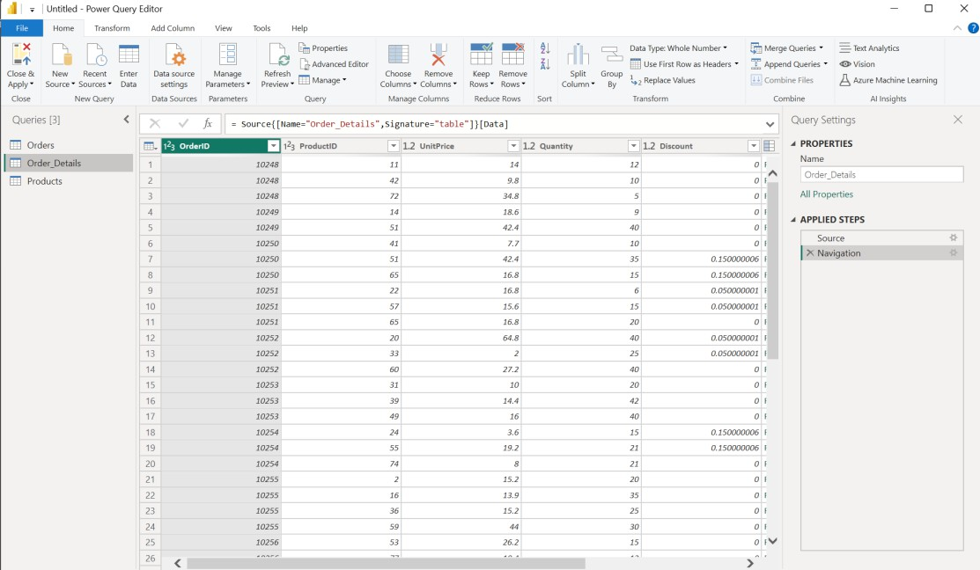

Step 4: Remove duplicate entries by right clicking on the column and selecting Remove Duplicates.

